QN1
SIMPLE LOGIN SYSTEM
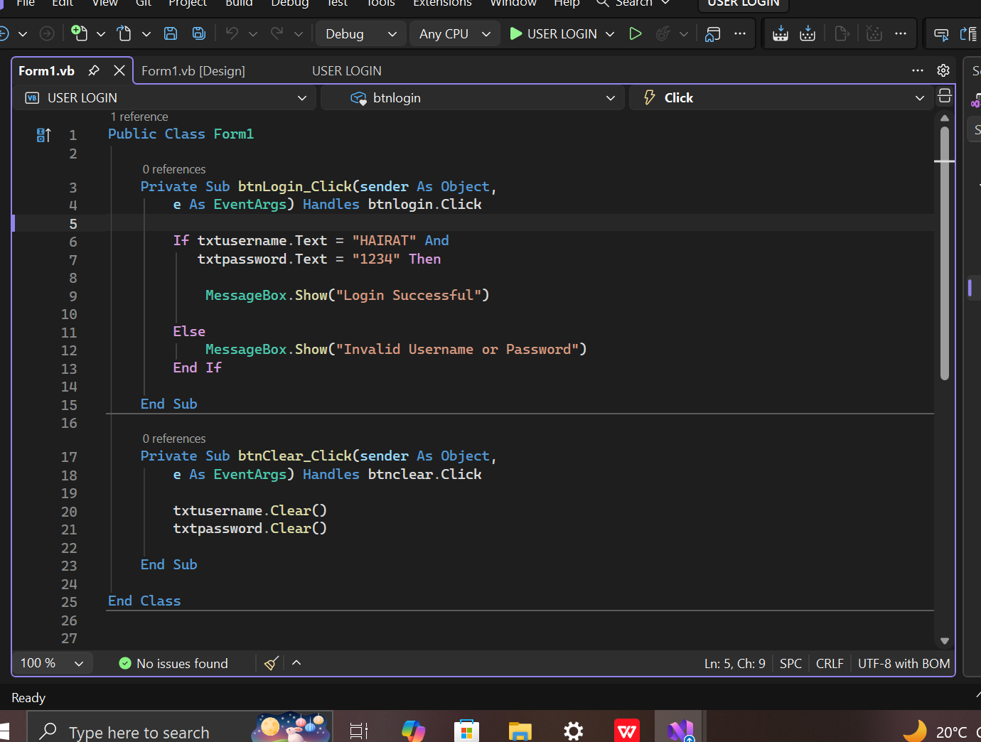
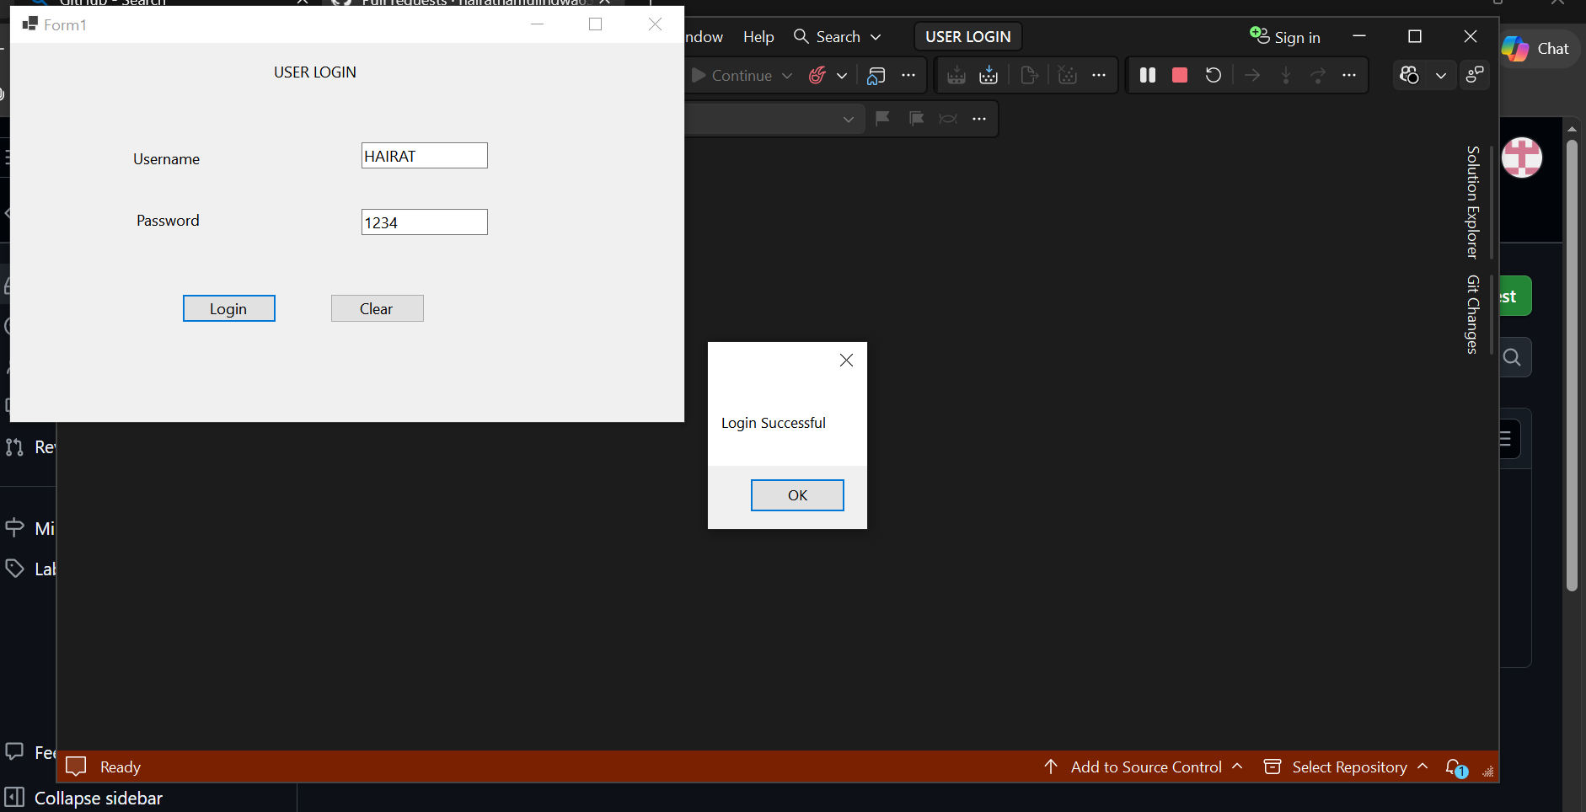

QN2
VISUAL BASIC APLICATION FOR A SHOPPING MALL
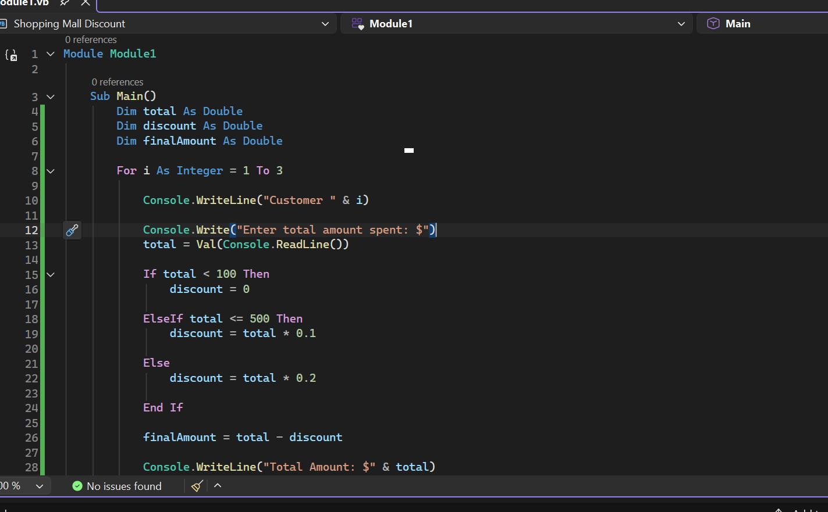
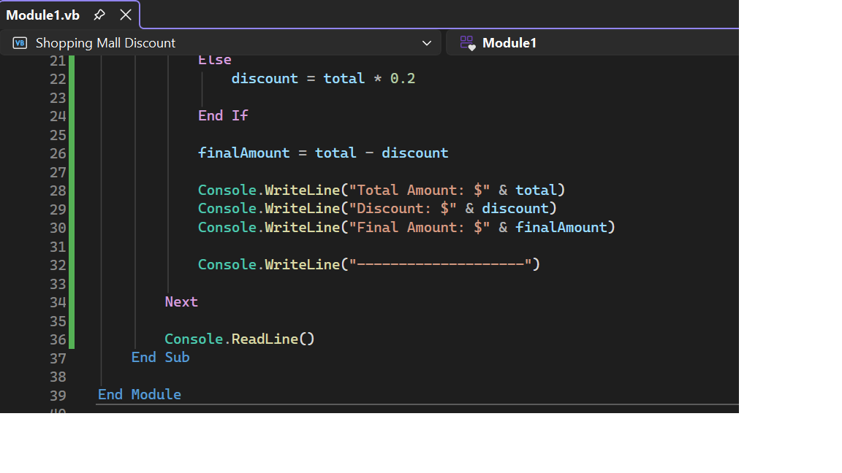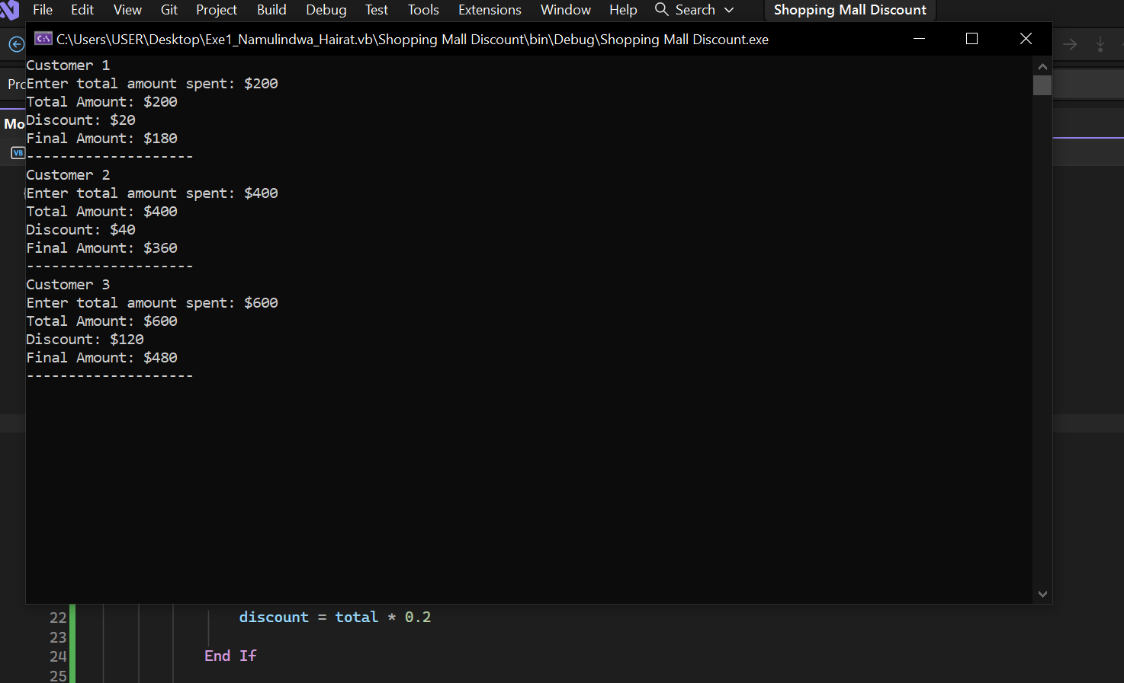

QN3
Class; A class is a blue print or template used to create objects. Defines the properties and methods that an object will have.
Object; An object is an instance of a class.
It represents something created using the class.
Example in visual basic
Public Class Student
Public Name As String
Public Sub Display()
MessageBox(“Student Name: “& Name)
End Sub
Creating an object:
Dim s As New Student()
s.Name=”Hairat”
s.Display()
Explanation: Student is the class while s is an object created from the class
Difference between inheritance and polymorphism
Inheritance | Polymorphism
Allows one class to acquire properties and methods of another class. | Allows the same method name or interface to have different behaviors.
Promotes code reuse. | Promotes flexibility and allows different implementations.
Uses the Inherits keywords in VB. | Can be implemented using method overriding or overloading.
Example of inheritance
Public Class Animal
Public Sub Eat()
messageBox(“Animal is eating”)
End Sub
End Class
Public Class Dog
Inherits Animal
Example of polymorphism:
Public Class Animal
Public Overridable Sub
Sound(0
MessageBox(“Animal sound”)
End Sub
End Class
Public Class Dog
Inherits Animal
Public Overrides Sub
Sound()
MessageBox.Show(“Dog barks”)
End Sub
Encapsulation is the process of combining data and methods into a single clas while restricting direct access to the data.
Importance
Protects data from unauthorized access.
Improves data security.
Makes programs easier to maintain.
Allows controlled access to data through properties and methods.
Example:
Public Class BankAccount

Private balance As Double

Public Property Balance As Double
Get
Return balance
End Get
Set(value As Double)
If value >= 0 Then
balance = value
End If
End Set
End Property
End Class
The balance variable is private , so it cannot be accessed directly outside the class. The balance property provides controlled access.
Constructor is a special method that runs automatically when an object is created.
Public Class Student

Public Name As String

Public Sub New()
Name = "Unknown"
End Sub
End Class
When an object is created:
Dim s As New Student()
The constructor automatically sets the student’s name to unknown
Destructor is used to perform clean up when an object is being destroyed.In VB.NET, the destructor-like method is called a finalizer and is written using finalize
Example:
Public Class Student

Protected Overrides Sub Finalize()
Try
MsgBox("Object is being destroyed")
Finally
MyBase.Finalize()
End Try
End Sub

End Class
The finalizer is called by garbage collector when the object is being cleaned UP.
Difference: A constructor initializes an object when it is created, while a finalizer performs cleanup when the object is being collected.

QN4
A collection is an object used to store and manage multiple items in a single variable.
Uses
Storing multiple values
Easy data management
Dynamic storage
Example
Dim students As New List(Of String)

students.Add("Hairat")
students.Add("Patricia")

MsgBox(students(0))
Output: Hairat.
Amessage box is a dialog box used to display information, warnings, errors, or ask users questions.
Example:
MsgBox("Welcome to VB")
Types of messageBoxes
Type | Purpose
Information | Displays general information
Warning | Warns the user about a possible problem
error | Displays an error message
Yes/no | Allows user to choose yes or no
Example:
MsgBox("Are you sure?", MsgBoxStyle.YesNo)
This displays a message with yes and no buttons
Functions of solution explorer:
File management
Add files
Opening files
Project organization
Renaming and deleting
Viewing project structure

QN5
Input and validation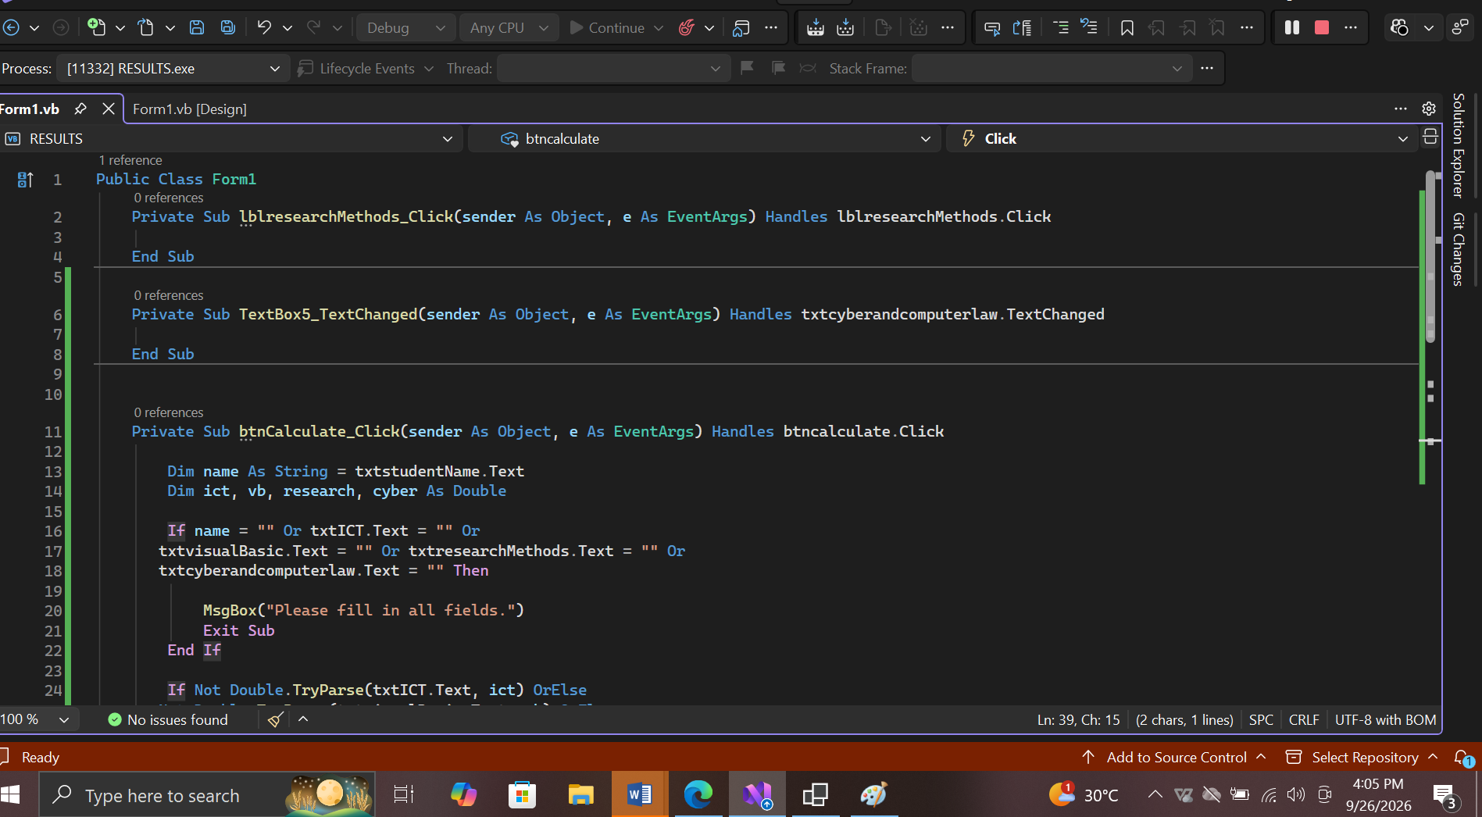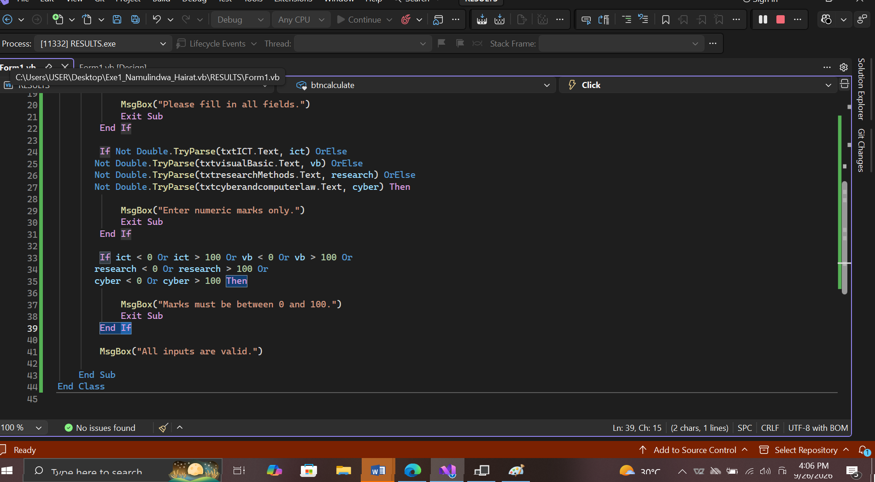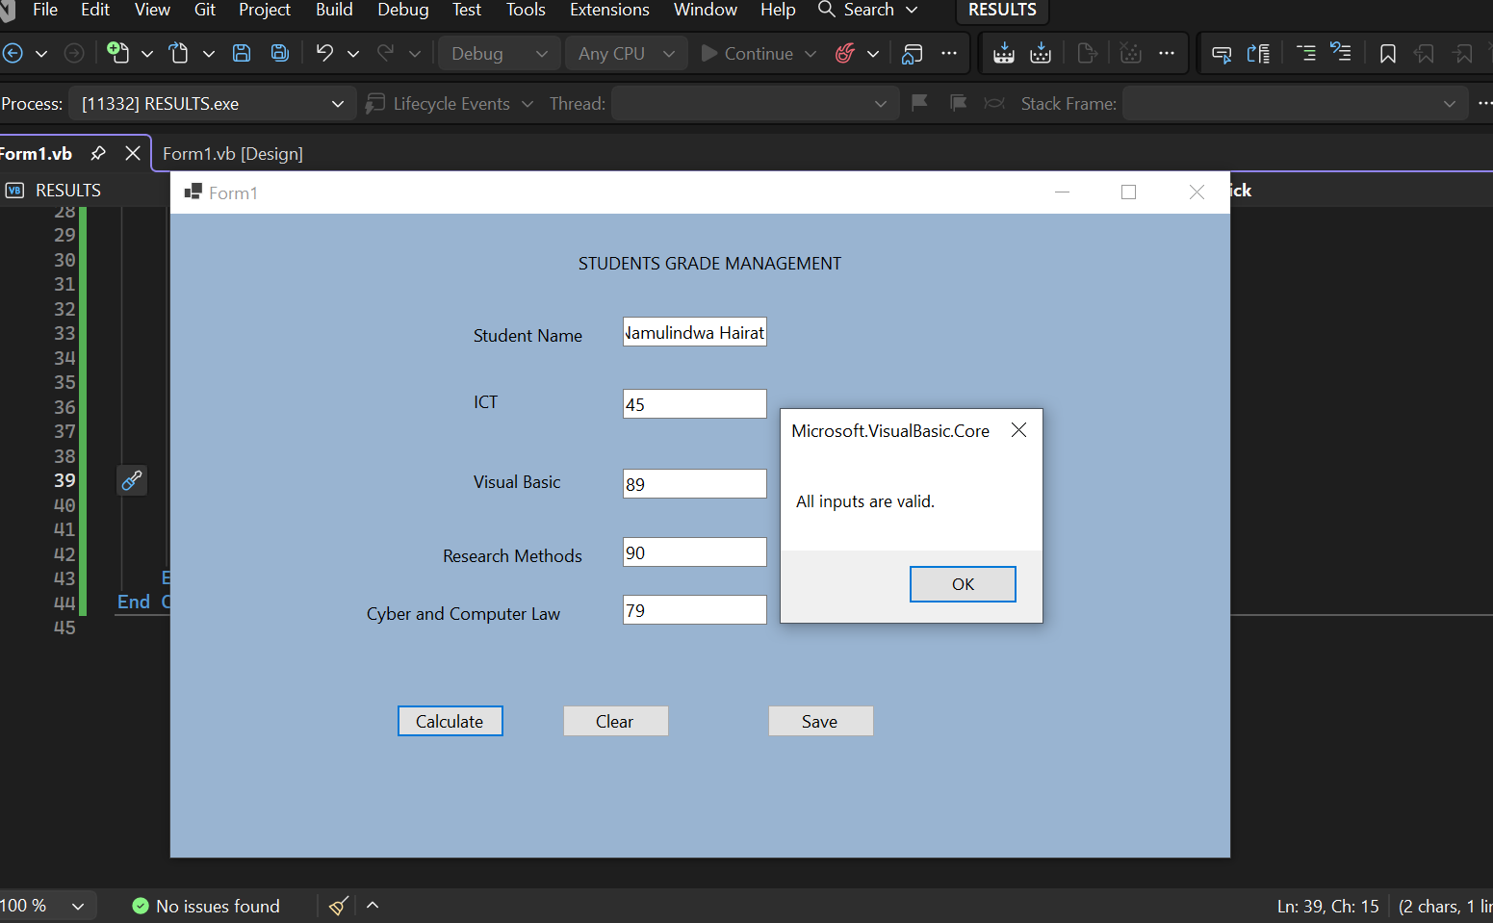
Calculations and grading
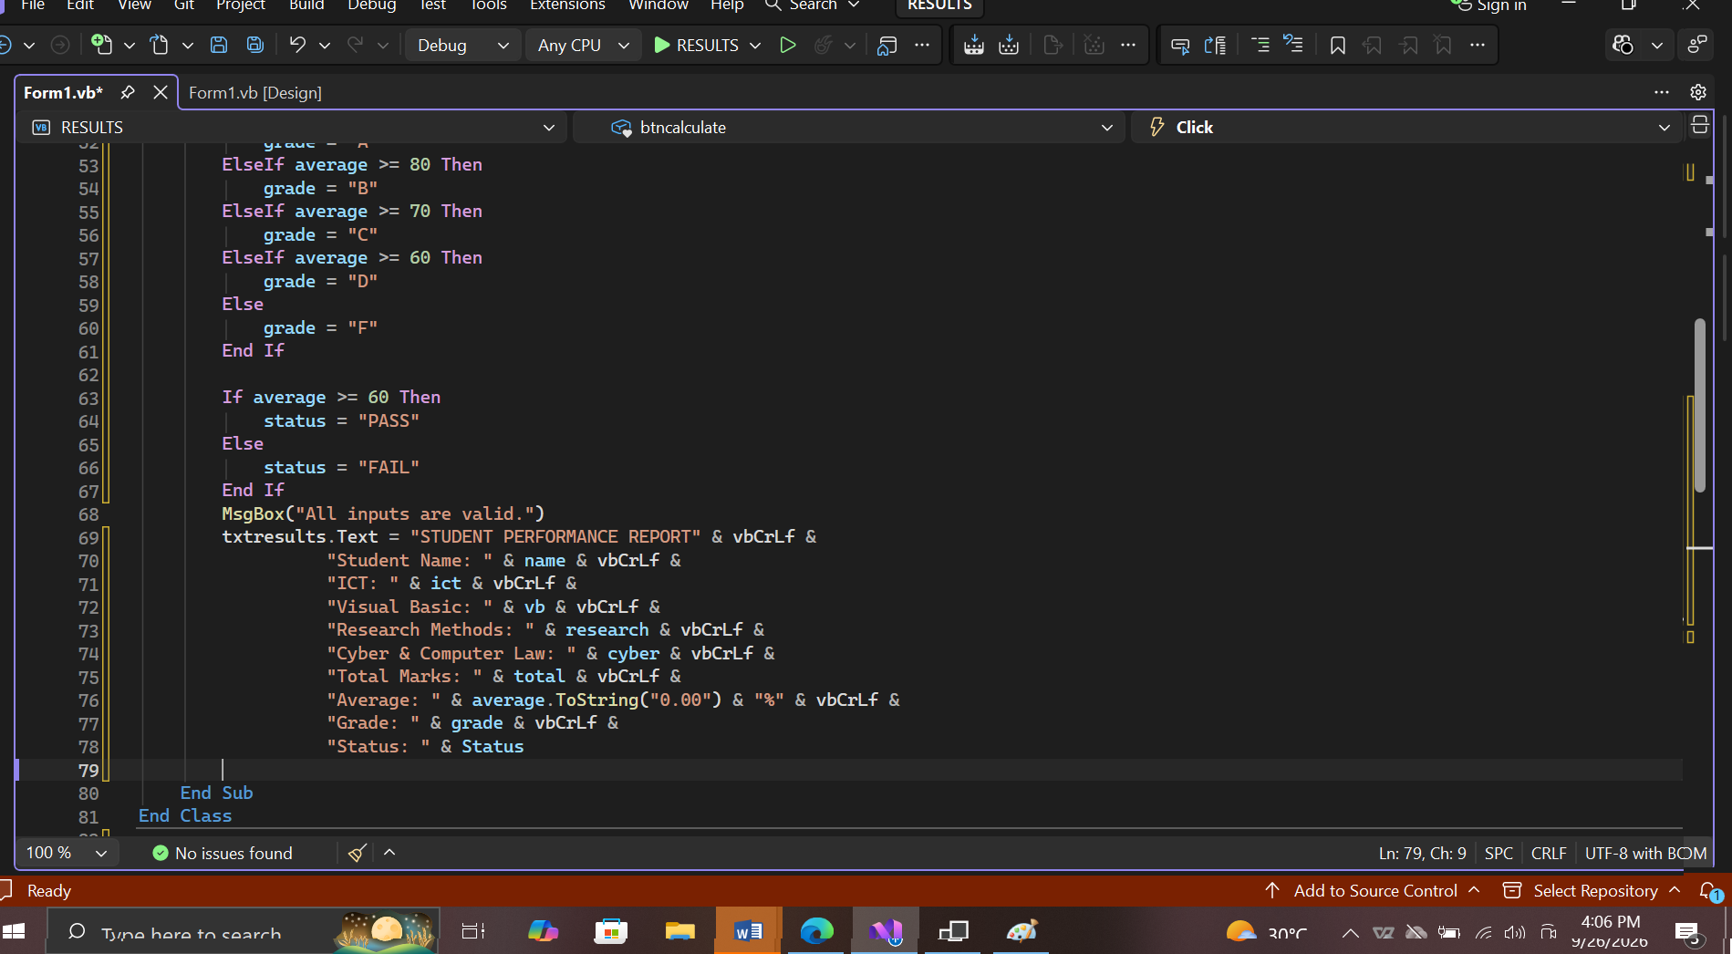
Output and reporting
